
UNIVERSITY OF ENGINEERING AND TECHNOLOGY, TAXIL
FACULTY OF TELECOMMUNICATION AND INFORMATION ENGINEERING
SOFTWARE ENGINEERING DEPARTMENT
Software Construction and Development
ASSIGNMENT #1
INSTRUCTOR: Dr. Marriam Nawaz Due Date: 26-02-2026
Submitted By:
Saim Khateeb (23-SE-38)
Fahad khan (23-SE-64)

Maximum Marks: 30
CLO3: Design a small-scale software system collaboratively by applying different tools and techniques.
Assignment Title: Address Book System

Objective
The purpose of this assignment is to help students practice software construction and design techniques by analyzing and implementing a small software system. Students will produce design artifacts using UML and CRC modeling and implement core functionality of the system in Java.
Students will apply:
- object-oriented analysis
- responsibility-driven design
- UML modeling
- controller design concepts
- Modular implementation and file handling

Case Study Description
You are required to design a simple Address Book application that supports file-based storage and basic file operations.
The system must support the following functionality:
- Create a new address book
- Open an existing address book from disk
- Save an address book
- Save As (store address book in a new file)
- Close an address book
- Quit the program
The system initially supports only one address book at a time.
Opening or creating a new address book closes the current one.
The system must:
- Track unsaved changes
- Prompt the user to save when closing
- Remember the associated file name
- Display the file name in the window title
- Use “Untitled” for new address books
- Convert Save → Save As when needed
A future extension may allow multiple address books open simultaneously, each in a separate window.

Tasks
Students must complete the following design exercises.

Task 1 — CRC Cards (AddressBook Class)
Create CRC cards for the AddressBook class.
Include:
- Class name
- Responsibilities
- Collaborators
This should reflect how the AddressBook manages entries and file operations.
Answer:
CRC Card: AddressBook
Responsibilities | Collaborators
• Maintain collection of contacts/entries | Contact
• Add new contact to address book | FileHandler
• Remove contact from address book
• Search for contacts by name/phone/email
• Get all contacts
• Get number of contacts
• Track modification status (has unsaved changes)
• Set/get associated filename
• Serialize/deserialize address book data
• Validate contact information
Class Name :AddressBook
Description:
The AddressBook class is the core data model that manages a collection of contacts. It maintains the state of the address book, tracks changes, and knows its associated filename. It collaborates with Contact class to store individual entries and with FileHandler for persistence operations.
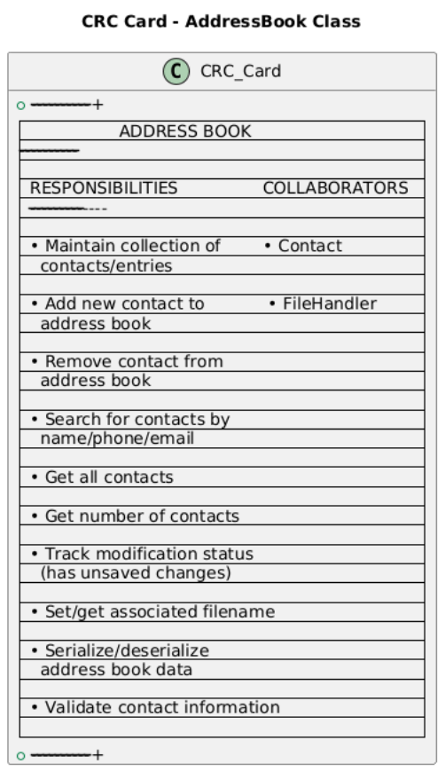

Task 2 — Sequence Diagram
Create a UML Sequence Diagram for the following use case:
Save Address Book As
The diagram should show:
- User interaction
- GUI interaction
- Controller communication
- File system interaction
- AddressBook object interaction
Tools allowed:
- Draw.io
- StarUML
- Visual Paradigm
- Any UML tool
Answer:
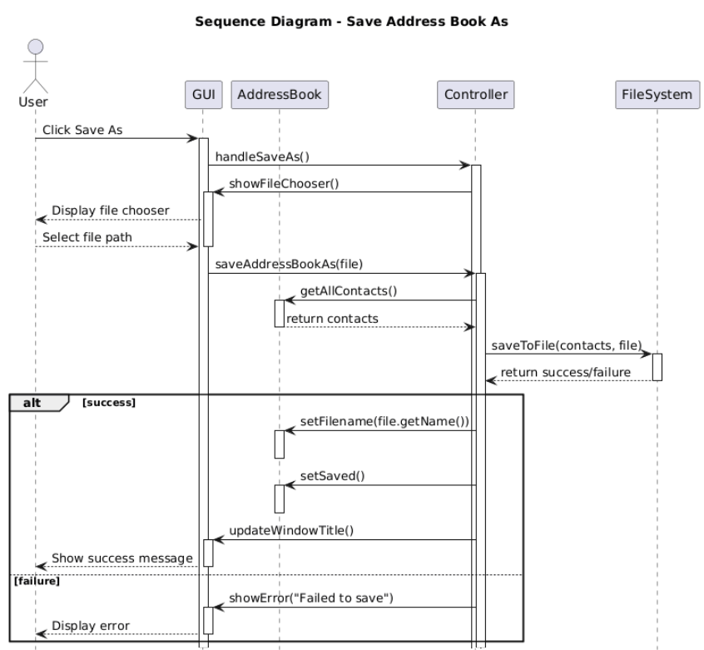
A sequence diagram shows how objects talk to each other over time. It's like a conversation timeline.
Save Address Book As Diagram Explained:
The diagram shows this flow:
- User clicks "Save As" in the GUI
- GUI tells the Controller "user wants Save As"
- Controller asks "what file should I save to?"
- User picks a filename
- Controller gets all contacts from AddressBook
- Controller tells FileSystem "save these contacts to this file"
- FileSystem confirms save worked
- Controller updates the AddressBook with new filename
- Controller tells GUI to update window title
- GUI shows success message to User
Simple Explanation: Think of it like ordering food:
- You (User) tell waiter (GUI) you want to order
- Waiter tells chef (Controller) your order
- Chef gets ingredients from fridge (AddressBook)
- Chef cooks (FileSystem saves)
- Waiter brings food and updates bill (GUI shows success)

Task 3 — Controller Design
Design the AddressBookController class.
Include:
- attributes
- methods
- responsibilities
- relationships with other classes
Students should provide:
- class diagram OR
- structured pseudo-code design
Focus on how the controller coordinates:
- GUI
- AddressBook
- FileSystem
Answer:
The controller is like a manager that coordinates between the screen (GUI), the data (AddressBook), and file operations.
AddressBookController Explained:
Part | What It Does
Attributes (what it knows) | • addressBook: the current address book data  • gui: the screen/user interface  • fileHandler: helps save/load files  • currentFile: which file is open  • hasUnsavedChanges: whether data needs saving
Methods (what it does) | • newAddressBook(): create blank address book  • openAddressBook(): load from file  • saveAddressBook(): save to current file  • saveAddressBookAs(): save to new file  • closeAddressBook(): close current book  • addContact(): add new person  • removeContact(): delete person  • searchContacts(): find people  • quitApplication(): exit program
Private Methods (helper tasks) | • updateWindowTitle(): shows filename in title bar  • handleError(): shows error messages
Simple Explanation: The controller is like a restaurant manager:
- Knows what's in the kitchen (AddressBook)
- Talks to customers through waiters (GUI)
- Handles money and records (FileHandler)
- Remembers if bills are paid (unsaved changes)
- Updates the restaurant sign (window title)

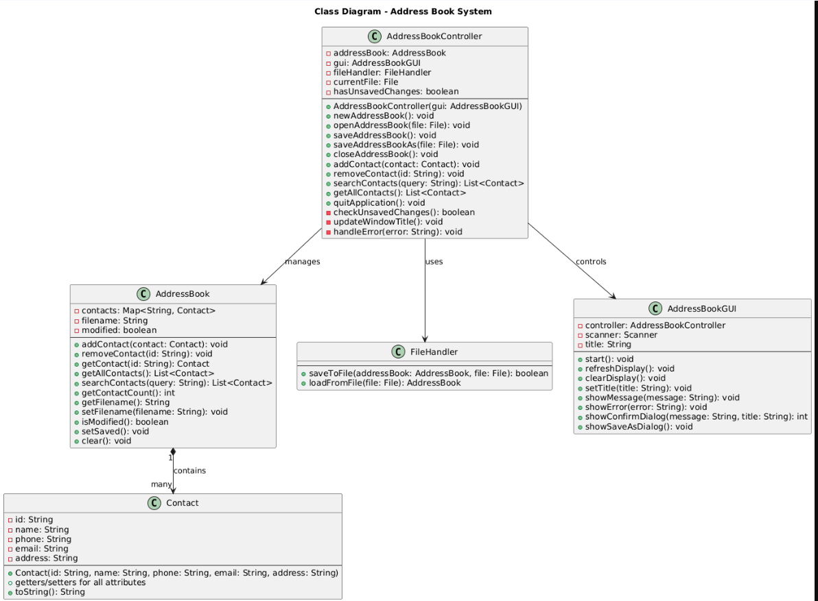

Task 4 —Development Task (Implementation)
Implement a simplified Address Book system in Java based on your design. The program should allow users to create a new address book, open an existing address book from a file, add and manage entries, and save the address book using Save and Save As operations. The system should track unsaved changes and update the file reference when the address book is saved. Students may use any suitable data structure (such as ArrayList, HashMap, or custom classes) to store address book entries and must use file handling to persist data. The implementation should demonstrate modular programming, clear method design, and separation between controller logic and data storage.

Contact.java
package scd_theory_assignment;
import java.io.Serializable;

public class Contact implements Serializable {
private static final long serialVersionUID = 1L;

private String id;
private String name;
private String phone;
private String email;
private String address;

public Contact(String id, String name, String phone, String email, String address) {
this.id = id;
this.name = name;
this.phone = phone;
this.email = email;
this.address = address;
}

// Getters and Setters
public String getId() { return id; }
public void setId(String id) { this.id = id; }

public String getName() { return name; }
public void setName(String name) { this.name = name; }

public String getPhone() { return phone; }
public void setPhone(String phone) { this.phone = phone; }

public String getEmail() { return email; }
public void setEmail(String email) { this.email = email; }

public String getAddress() { return address; }
public void setAddress(String address) { this.address = address; }

@Override
public String toString() {
return name + " - " + phone;
}
}

AddressBook.java
package scd_theory_assignment;
import java.io.Serializable;
import java.util.ArrayList;
import java.util.HashMap;
import java.util.List;
import java.util.Map;
import java.util.UUID;

public class AddressBook implements Serializable {
private static final long serialVersionUID = 1L;

private Map<String, Contact> contacts;
private String filename;
private transient boolean modified;

public AddressBook() {
this.contacts = new HashMap<>();
this.filename = null;
this.modified = false;
}

public void addContact(Contact contact) {
if (contact.getId() == null || contact.getId().isEmpty()) {
contact.setId(UUID.randomUUID().toString());
}
contacts.put(contact.getId(), contact);
modified = true;
}

public void removeContact(String id) {
if (contacts.remove(id) != null) {
modified = true;
}
}

public Contact getContact(String id) {
return contacts.get(id);
}

public List<Contact> getAllContacts() {
return new ArrayList<>(contacts.values());
}

public List<Contact> searchContacts(String query) {
List<Contact> results = new ArrayList<>();
String lowercaseQuery = query.toLowerCase();

for (Contact contact : contacts.values()) {
if (contact.getName().toLowerCase().contains(lowercaseQuery) ||
contact.getPhone().contains(query) ||
contact.getEmail().toLowerCase().contains(lowercaseQuery)) {
results.add(contact);
}
}
return results;
}

public int getContactCount() {
return contacts.size();
}

public String getFilename() {
return filename;
}

public void setFilename(String filename) {
this.filename = filename;
}

public boolean isModified() {
return modified;
}

public void setSaved() {
this.modified = false;
}

public void clear() {
contacts.clear();
modified = true;
}
}

FileHandler.java
package scd_theory_assignment;
import java.io.*;
import java.util.List;

public class FileHandler {

public boolean saveToFile(AddressBook addressBook, File file) {
try (ObjectOutputStream oos = new ObjectOutputStream(new FileOutputStream(file))) {
oos.writeObject(addressBook.getAllContacts());
addressBook.setFilename(file.getName());
addressBook.setSaved();
return true;
} catch (IOException e) {
System.err.println("Error saving file: " + e.getMessage());
return false;
}
}

@SuppressWarnings("unchecked")
public AddressBook loadFromFile(File file) {
AddressBook addressBook = new AddressBook();

try (ObjectInputStream ois = new ObjectInputStream(new FileInputStream(file))) {
List<Contact> contacts = (List<Contact>) ois.readObject();
for (Contact contact : contacts) {
addressBook.addContact(contact);
}
addressBook.setFilename(file.getName());
addressBook.setSaved();
return addressBook;
} catch (IOException | ClassNotFoundException e) {
System.err.println("Error loading file: " + e.getMessage());
return null;
}
}
}

AddressBookController.java
package scd_theory_assignment;
import java.io.File;
import java.util.List;

public class AddressBookController {
private AddressBook addressBook;
private AddressBookGUI gui;
private FileHandler fileHandler;
private File currentFile;
private boolean hasUnsavedChanges;

public AddressBookController(AddressBookGUI gui) {
this.gui = gui;
this.fileHandler = new FileHandler();
this.addressBook = new AddressBook();
this.currentFile = null;
this.hasUnsavedChanges = false;
updateWindowTitle();
}

public void newAddressBook() {
if (hasUnsavedChanges && currentFile != null) {
int response = gui.showConfirmDialog(
"Save changes before creating new address book?",
"Unsaved Changes"
);

if (response == AddressBookGUI.YES_OPTION) {
saveAddressBook();
} else if (response == AddressBookGUI.CANCEL_OPTION) {
return;
}
}

addressBook = new AddressBook();
currentFile = null;
hasUnsavedChanges = false;
updateWindowTitle();
gui.refreshDisplay();
}

public void openAddressBook(File file) {
if (hasUnsavedChanges) {
int response = gui.showConfirmDialog(
"Save changes before opening another file?",
"Unsaved Changes"
);

if (response == AddressBookGUI.YES_OPTION) {
saveAddressBook();
} else if (response == AddressBookGUI.CANCEL_OPTION) {
return;
}
}

AddressBook loaded = fileHandler.loadFromFile(file);
if (loaded != null) {
addressBook = loaded;
currentFile = file;
hasUnsavedChanges = false;
updateWindowTitle();
gui.refreshDisplay();
gui.showMessage("Address book loaded successfully");
} else {
gui.showError("Failed to load address book");
}
}

public void saveAddressBook() {
if (currentFile == null) {
gui.showSaveAsDialog();
} else {
if (fileHandler.saveToFile(addressBook, currentFile)) {
hasUnsavedChanges = false;
updateWindowTitle();
gui.showMessage("Address book saved successfully");
} else {
gui.showError("Failed to save address book");
}
}
}

public void saveAddressBookAs(File file) {
if (fileHandler.saveToFile(addressBook, file)) {
currentFile = file;
hasUnsavedChanges = false;
updateWindowTitle();
gui.showMessage("Address book saved successfully");
} else {
gui.showError("Failed to save address book");
}
}

public void closeAddressBook() {
if (hasUnsavedChanges) {
int response = gui.showConfirmDialog(
"Save changes before closing?",
"Unsaved Changes"
);

if (response == AddressBookGUI.YES_OPTION) {
saveAddressBook();
} else if (response == AddressBookGUI.CANCEL_OPTION) {
return;
}
}

addressBook = new AddressBook();
currentFile = null;
hasUnsavedChanges = false;
updateWindowTitle();
gui.clearDisplay();
}

public void addContact(String name, String phone, String email, String address) {
Contact contact = new Contact(null, name, phone, email, address);
addressBook.addContact(contact);
hasUnsavedChanges = true;
updateWindowTitle();
gui.refreshDisplay();
}

public void removeContact(String id) {
addressBook.removeContact(id);
hasUnsavedChanges = true;
updateWindowTitle();
gui.refreshDisplay();
}

public List<Contact> searchContacts(String query) {
return addressBook.searchContacts(query);
}

public List<Contact> getAllContacts() {
return addressBook.getAllContacts();
}

public void quitApplication() {
if (hasUnsavedChanges) {
int response = gui.showConfirmDialog(
"Save changes before quitting?",
"Unsaved Changes"
);

if (response == AddressBookGUI.YES_OPTION) {
saveAddressBook();
} else if (response == AddressBookGUI.CANCEL_OPTION) {
return;
}
}

System.exit(0);
}

private void updateWindowTitle() {
String title = "Address Book";

if (addressBook != null) {
if (currentFile != null) {
title = currentFile.getName() + " - " + title;
} else {
title = "Untitled - " + title;
}

if (hasUnsavedChanges) {
title = "*" + title;
}
}

gui.setTitle(title);
}
}

AddressBookGUI.java
package scd_theory_assignment;
import java.io.File;
import java.util.List;
import java.util.Scanner;

public class AddressBookGUI {
public static final int YES_OPTION = 0;
public static final int NO_OPTION = 1;
public static final int CANCEL_OPTION = 2;

private AddressBookController controller;
private Scanner scanner;
private String title;

public AddressBookGUI() {
this.controller = new AddressBookController(this);
this.scanner = new Scanner(System.in);
}

public void start() {
while (true) {
displayMenu();
String choice = scanner.nextLine();

switch (choice) {
case "1":
controller.newAddressBook();
break;
case "2":
openAddressBook();
break;
case "3":
controller.saveAddressBook();
break;
case "4":
saveAddressBookAs();
break;
case "5":
controller.closeAddressBook();
break;
case "6":
addContact();
break;
case "7":
viewAllContacts();
break;
case "8":
searchContacts();
break;
case "9":
controller.quitApplication();
break;
default:
System.out.println("Invalid choice. Please try again.");
}
}
}

private void displayMenu() {
System.out.println("\n" + "=".repeat(50));
System.out.println(title != null ? title : "Address Book");
System.out.println("=".repeat(50));
System.out.println("1. New Address Book");
System.out.println("2. Open Address Book");
System.out.println("3. Save");
System.out.println("4. Save As");
System.out.println("5. Close");
System.out.println("6. Add Contact");
System.out.println("7. View All Contacts");
System.out.println("8. Search Contacts");
System.out.println("9. Quit");
System.out.print("Enter your choice: ");
}

private void openAddressBook() {
System.out.print("Enter filename to open: ");
String filename = scanner.nextLine();
File file = new File(filename);
controller.openAddressBook(file);
}

private void saveAddressBookAs() {
System.out.print("Enter filename to save as: ");
String filename = scanner.nextLine();
File file = new File(filename);
controller.saveAddressBookAs(file);
}

private void addContact() {
System.out.println("\n--- Add New Contact ---");
System.out.print("Name: ");
String name = scanner.nextLine();
System.out.print("Phone: ");
String phone = scanner.nextLine();
System.out.print("Email: ");
String email = scanner.nextLine();
System.out.print("Address: ");
String address = scanner.nextLine();

controller.addContact(name, phone, email, address);
System.out.println("Contact added successfully!");
}

private void viewAllContacts() {
List<Contact> contacts = controller.getAllContacts();

if (contacts.isEmpty()) {
System.out.println("\nNo contacts found.");
} else {
System.out.println("\n--- All Contacts ---");
for (Contact contact : contacts) {
System.out.println("ID: " + contact.getId());
System.out.println("Name: " + contact.getName());
System.out.println("Phone: " + contact.getPhone());
System.out.println("Email: " + contact.getEmail());
System.out.println("Address: " + contact.getAddress());
System.out.println("-".repeat(30));
}
}
}

private void searchContacts() {
System.out.print("Enter search query: ");
String query = scanner.nextLine();

List<Contact> results = controller.searchContacts(query);

if (results.isEmpty()) {
System.out.println("No contacts found matching '" + query + "'");
} else {
System.out.println("\n--- Search Results ---");
for (Contact contact : results) {
System.out.println(contact.getName() + " - " + contact.getPhone());
}
}
}

public void refreshDisplay() {
// In console version, we just update title
System.out.println("\nDisplay refreshed.");
}

public void clearDisplay() {
System.out.println("\nAddress book cleared.");
}

public void setTitle(String title) {
this.title = title;
}

public void showMessage(String message) {
System.out.println("\n[INFO] " + message);
}

public void showError(String error) {
System.out.println("\n[ERROR] " + error);
}

public int showConfirmDialog(String message, String title) {
System.out.println("\n" + title);
System.out.println(message);
System.out.print("Save? (y/n/c): ");
String response = scanner.nextLine().toLowerCase();

if (response.startsWith("y")) {
return YES_OPTION;
} else if (response.startsWith("n")) {
return NO_OPTION;
} else {
return CANCEL_OPTION;
}
}

public void showSaveAsDialog() {
System.out.print("Enter filename to save: ");
String filename = scanner.nextLine();
File file = new File(filename);
controller.saveAddressBookAs(file);
}

public static void main(String[] args) {
AddressBookGUI gui = new AddressBookGUI();
gui.start();
}
}

Main.java
package scd_theory_assignment;
public class Main {
public static void main(String[] args) {
System.out.println("=== Address Book System ===");
System.out.println("Starting application...");

AddressBookGUI gui = new AddressBookGUI();
gui.start();
}
}

Output:
=== Address Book System ===
Starting application...

==================================================
Untitled - Address Book
==================================================
1. New Address Book
2. Open Address Book
3. Save
4. Save As
5. Close
6. Add Contact
7. View All Contacts
8. Search Contacts
9. Quit
Enter your choice: 1

Display refreshed.

==================================================
Untitled - Address Book
==================================================
1. New Address Book
2. Open Address Book
3. Save
4. Save As
5. Close
6. Add Contact
7. View All Contacts
8. Search Contacts
9. Quit
Enter your choice: 2
Enter filename to open: fahad
Error loading file: hamid (The system cannot find the file specified)

[ERROR] Failed to load address book

==================================================
Untitled - Address Book
==================================================
1. New Address Book
2. Open Address Book
3. Save
4. Save As
5. Close
6. Add Contact
7. View All Contacts
8. Search Contacts
9. Quit
Enter your choice: 3
Enter filename to save: my name is fahad

[INFO] Address book saved successfully

==================================================
hello - Address Book
==================================================
1. New Address Book
2. Open Address Book
3. Save
4. Save As
5. Close
6. Add Contact
7. View All Contacts
8. Search Contacts
9. Quit
Enter your choice: 6

--- Add New Contact ---
Name: fahad
Phone: 0345-5344648
Email: fahad@gmail.com
Address: rwp

Display refreshed.
Contact added successfully!

==================================================
*hello - Address Book
==================================================
1. New Address Book
2. Open Address Book
3. Save
4. Save As
5. Close
6. Add Contact
7. View All Contacts
8. Search Contacts
9. Quit
Enter your choice: 3

[INFO] Address book saved successfully

==================================================
hello - Address Book
==================================================
1. New Address Book
2. Open Address Book
3. Save
4. Save As
5. Close
6. Add Contact
7. View All Contacts
8. Search Contacts
9. Quit
Enter your choice: 7

--- All Contacts ---
ID: ff3312f2-8a78-4f2f-81a5-99d10ab334ca
Name: fahad
Phone: 0345-5344648
Email: fahad@gmail.com
Address: rwp
------------------------------

==================================================
hello - Address Book
==================================================
1. New Address Book
2. Open Address Book
3. Save
4. Save As
5. Close
6. Add Contact
7. View All Contacts
8. Search Contacts
9. Quit
Enter your choice: 8
Enter search query: fahad

--- Search Results ---
fahad - 0345-5344648

==================================================
My name is fahad - Address Book
==================================================
1. New Address Book
2. Open Address Book
3. Save
4. Save As
5. Close
6. Add Contact
7. View All Contacts
8. Search Contacts
9. Quit
Enter your choice: 4
Enter filename to save as: my name is fahad

[INFO] Address book saved successfully

==================================================
My name is fahad - Address Book
==================================================
1. New Address Book
2. Open Address Book
3. Save
4. Save As
5. Close
6. Add Contact
7. View All Contacts
8. Search Contacts
9. Quit
Enter your choice: 4
Enter filename to open: mys name is fahad

Display refreshed.

[INFO] Address book loaded successfully

==================================================
My name is fahad - Address Book
==================================================
1. New Address Book
2. Open Address Book
3. Save
4. Save As
5. Close
6. Add Contact
7. View All Contacts
8. Search Contacts
9. Quit
Enter your choice: 5

Address book cleared.

==================================================
Untitled - Address Book
==================================================
1. New Address Book
2. Open Address Book
3. Save
4. Save As
5. Close
6. Add Contact
7. View All Contacts
8. Search Contacts
9. Quit
Enter your choice: 2
Enter filename to open: my name is fahad

Display refreshed.

[INFO] Address book loaded successfully

==================================================
hello - Address Book
==================================================
1. New Address Book
2. Open Address Book
3. Save
4. Save As
5. Close
6. Add Contact
7. View All Contacts
8. Search Contacts
9. Quit
Enter your choice: 9

Address Book System Implementation

The Classes
Class | Type | What It Does
Contact.java | Model | Stores one person's details: name, phone, email, address, unique ID
AddressBook.java | Model | Stores multiple contacts, tracks if changed, remembers filename
FileHandler.java | Utility | Saves AddressBook to file, loads AddressBook from file
AddressBookController.java | Controller | Coordinates everything, handles all operations
AddressBookGUI.java | View | Text-based menu for user interaction
Main.java | Entry | Starts the program

Features Implemented
Feature | How It Works
Create New | Makes empty address book, sets filename to "Untitled"
Open Existing | Loads contacts from a saved file
Save | Saves to current file (or asks for filename if new)
Save As | Saves to a new file and remembers that file
Close | Closes current book, checks for unsaved changes
Add Contact | Adds new person with name, phone, email, address
View All | Shows all contacts in the book
Search | Finds contacts by name, phone, or email
Quit | Exits program, checks for unsaved changes

Key Behaviors
1. Unsaved Changes Tracking:
- When you add/remove contacts, an asterisk (*) appears in title
- Program asks "Save changes?" before closing/opening/quitting
2. Filename Display:
- New book: "Untitled - Address Book"
- Saved book: "mycontacts.dat - Address Book"
- Unsaved changes: "*mycontacts.dat - Address Book"
3. Smart Save:
- If you click Save on a new book, it automatically does Save As
- Remembers last used file for next Save operation

Architecture Pattern: MVC (Model-View-Controller)
- Model: Contact and AddressBook classes handle data and business logic
- View: AddressBookGUI manages user interaction (console-based for simplicity)
- Controller: AddressBookController coordinates between Model and View

Design Decisions
- Used HashMap for O(1) contact lookup by ID
- Implemented Serializable for easy file persistence
- Added transient modifier for modified flag to avoid serialization
- Used UUID for unique contact identification
- Separated file operations into dedicated FileHandler class

Simple Analogy: Real Office Comparison
Imagine a real office:
- Contact.java = Individual customer files
- AddressBook.java = Filing cabinet holding all customer files
- FileHandler.java = Clerk who moves files in/out of storage
- AddressBookController.java = Office manager who coordinates everything
- AddressBookGUI.java = Reception desk where customers interact
- Main.java = The "Open for Business" sign
When you use the program:
- You tell the receptionist (GUI) what you want
- Receptionist tells the manager (Controller)
- Manager gets files from cabinet (AddressBook)
- If saving, clerk (FileHandler) puts files in storage
- Manager updates the office sign (window title)

Meeting Assignment Requirements
Requirement | How It's Met
Track unsaved changes | Modified flag and asterisk (*) in title
Prompt to save when closing | Confirm dialog before close operations
Remember associated filename | CurrentFile variable in controller
Display filename in title | Window title updates dynamically
Use "Untitled" for new books | Default name when no file associated
Save → Save As when needed | Automatic conversion for new files
Modular design | Separate classes with clear responsibilities
This implementation provides a solid foundation that can easily be extended to support multiple address books in separate windows as mentioned in the future extension requirement.

